Chapter 4, Problem 93.

The circuit in Fig. 4.149 models a common-emitter transistor amplifier. Find i_{x} using source transformation.

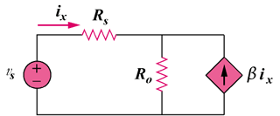

Figure 4.149
For Prob. 4.93.

